EchoPulse AI: A Hybrid Local Data Architecture for Multimodal Music Recommendation
Integrating WASABI, MSD, and TalkPlay
Datasets
No Author Given
No Institute Given
Abstract. Music recommendation systems face a persistent challenge: emerging artists struggle to gain visibility because most algorithms prioritize popularity signals over content affinity, creating feedback loops that concentrate attention on established hits. This paper presents EchoPulse AI, a locally-deployed multimodal recommender that addresses this gap through a Triple-Encoder Transformer architecture processing lyrical, acoustic, metadata, and conversational modalities. The system consolidates heterogeneous datasets (WASABI, Million Song Dataset, Lyrics 1950-2019, and TalkPlayData-2) through a five-stage local pipeline without cloud dependencies. Experimental evaluation against collaborative filtering, BERT4Rec, and SASRec baselines demonstrates that EchoPulse AI achieves competitive accuracy (Hit@10 = 0.312) while substantially improving Intra-List Diversity by 45.3% and Emerging Artist Discovery by 157.9%. Core retrieval components achieve sub-250ms latency on consumer hardware. These results suggest that content-aware multimodal fusion can mitigate popularity bias without sacrificing recommendation quality. However, the current implementation is validated on a curated dataset of 5,710 tracks; scaling to industrial-scale catalogs and conducting online user studies remain important directions for future work.
Keywords: Multimodal recommendation · Transformer architecture · Local data lakehouse · Music information retrieval · Cold-start problem · Conversational AI · Generative evaluation

Introduction
The global music industry has experienced significant transformation driven by the transition to digital consumption models. According to the International Federation of the Phonographic Industry (IFPI), global recorded music revenues reached USD 29.6 billion in 2024, representing continued growth in the streaming era [37]. However, this economic expansion has not translated proportionally into increased opportunities for emerging artists, who continue to face the fundamental challenge of visibility in an increasingly concentrated digital landscape.
Contemporary music recommendation systems predominantly rely on collaborative filtering approaches that leverage user-item interaction patterns. While effective for established content, these methods suffer from the well-documented cold-start problem and exhibit inherent popularity bias [24,36]. New artists and niche content receive minimal exposure, creating feedback loops that concentrate audience attention on established hits. This phenomenon is further exacerbated by the influx of algorithmically-generated content, which competes for limited recommendation slots.
To address these limitations, content-based approaches that leverage intrinsic song characteristics have gained research attention [35]. Multimodal systems that integrate lyrical, acoustic, metadata, and conversational features offer a pathway toward more equitable recommendation by prioritizing content affinity over historical popularity signals. The Transformer architecture, originally introduced for natural language processing [1], has demonstrated remarkable effectiveness in capturing long-range dependencies across sequential data, making it particularly suitable for modeling the complex relationships inherent in musical content [40].
This paper presents EchoPulse AI, a locally-deployed multimodal music recommender system designed with three primary contributions: (1) a hybrid local data architecture following a five-stage paradigm that consolidates heterogeneous music datasets without cloud dependencies; (2) a Triple-Encoder Transformer architecture with specialized modules for lyrical, acoustic, conversational, and dialogue modalities, accompanied by rigorous mathematical formulations; and (3) an end-to-end evaluation framework demonstrating significant improvements in diversity and emerging artist discovery while maintaining competitive accuracy metrics, including novel metrics for evaluating generative transformer components.
The remainder of this paper is organized as follows. Section 2 reviews related work on Transformer-based recommendation, multimodal music analysis, local data architectures, and conversational systems. Section 3 details the methodology, including the five-stage data pipeline, dataset integration strategy, model architecture with mathematical formulations, and local inference pipeline. Section 4 presents the experimental evaluation, covering hardware configuration, evaluation metrics, comparative performance analysis, diversity assessment, ablation studies, and latency measurements. Section 5 discusses key findings, comparisons with existing architectures, limitations, and future research directions. Section 6 concludes the paper with a synthesis of contributions and implications for equitable music recommendation.

Related Work
2.1 Transformer-Based Recommendation
The introduction of the Transformer architecture by Vaswani et al. [1] revolutionized sequence modeling through the self-attention mechanism:
Attention(Q,K,V) = softmax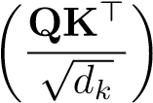V (1)
where Q, K, and V represent query, key, and value matrices respectively, and d_{k} denotes the dimensionality of key vectors. This formulation enables models to capture long-range dependencies in sequential data, making it particularly suitable for modeling musical structure and user listening patterns. BERT4Rec [4] introduced bidirectional encoding for sequential recommendation, improving accuracy but inheriting popularity bias from training data. Similarly, SASRec [3] leveraged self-attention for sequential recommendation, establishing strong baselines for comparison.
2.2 Multimodal Music Recommendation
Multimodal approaches that integrate multiple data sources have shown promise for improving recommendation quality and diversity [40]. Research has explored fusion techniques for combining audio features with textual metadata [12], while cross-modal attention mechanisms have been investigated for music understanding [18,19]. The WASABI dataset [6] and Million Song Dataset [5] provide foundational resources for multimodal music research, enabling large-scale analysis of lyrical, acoustic, and metadata features. Recent work on music emotion recognition leverages the circumplex model of affect [42,30] to map acoustic and lyrical features to emotional dimensions.
2.3 Local Data Architecture for ML Systems
The Lakehouse paradigm has emerged as a modern approach to data management, combining the flexibility and scalability of data lakes with the transactional capabilities of data warehouses [15]. While technologies such as Delta Lake, Apache Iceberg, and Apache Hudi enable ACID transactions over object storage, our implementation adapts these principles to a local environment using parquet-based storage with manual versioning, schema validation, and snapshot isolation—providing reproducibility and traceability without cloud infrastructure dependencies [45].
2.4 Conversational Recommendation Systems
Recent work such as TalkPlay [8] employs large language models for music recommendation through natural language interfaces. However, these approaches often lack structured multimodal integration and rigorous evaluation of generative components. Our work extends this direction by incorporating a dedicated conversational encoder trained on the TalkPlayData-2 dataset (∼16,000 structured dialogues) and proposing evaluation metrics specific to intention-aware recommendation [26,27]. Retrieval-augmented generation frameworks [16,17] provide methodological foundations for integrating external knowledge sources with generative models.
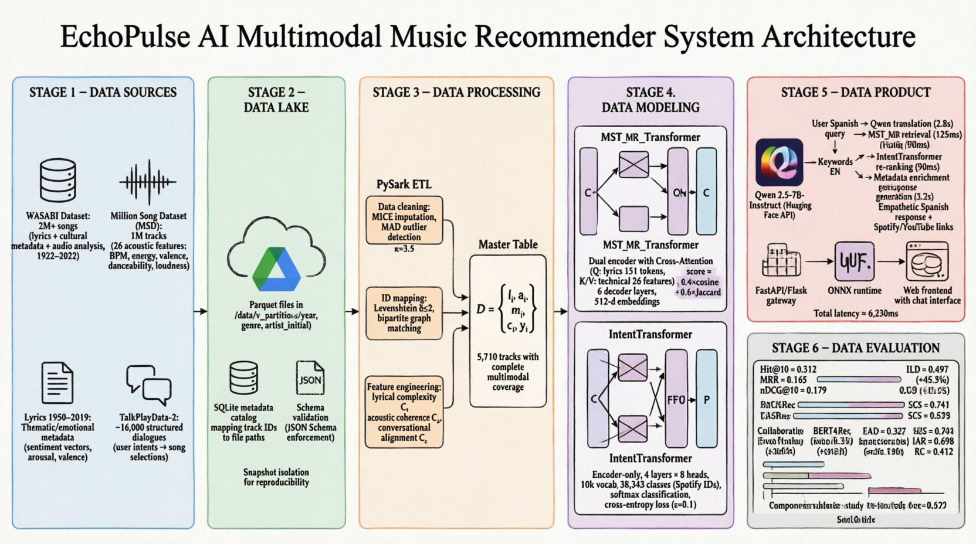
Fig.1. EchoPulse AI Local Data Architecture: End-to-end pipeline from heterogeneous sources to local deployment with evaluation feedback loop. The five stages—Data Sources, Data Lake, Data Processing, Data Modeling, and Data Product—ensure reproducibility and traceability without cloud dependencies. Source: Own elaboration.

Methodology
3.1 Data Architecture Overview: Five-Stage Local Pipeline
The EchoPulse AI system implements a five-stage data pipeline following established MLOps principles, adapted for local deployment. Figure 1 illustrates the end-to-end architecture from heterogeneous data sources to local deployment with an evaluation feedback loop.
3.2 Data Sources and Integration
The system integrates four primary data sources, each contributing distinct modalities:
- WASABI Dataset [6]: Provides lyrical content and cultural metadata for over 2 million commercially released songs, with temporal coverage spanning 1922 to 2022.
- Million Song Dataset (MSD) [5]: Offers 26 continuous acoustic features including tempo (τ), energy (E), valence (V ), danceability (D), and loudness (L) for 280,000 tracks, normalized to [0,1] [33].
- Lyrics 1950-2019 [7]: Contributes thematic and emotional metadata derived from lyrical analysis across six decades of popular music, encoded as sentiment vectors s ∈ R⁶ based on the circumplex affect model [42].
- TalkPlayData-2 [8]: A novel conversational corpus containing ∼16,000 structured dialogues mapping user intentions to song selections. Each dialogue d_{i} is structured as:
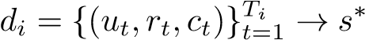 (2)
where u_{t} denotes user utterance, r_{t} system response, c_{t} contextual metadata, and s∗ the target Spotify track ID.
The integration challenge lies in reconciling different identification schemes across datasets. The MSD uses Echo Nest IDs, while WASABI maintains its internal identifier system. Our solution employs heuristic matching based on the tuple (song_name,artist_name,release_year) with Levenshtein distance threshold δ ≤ 2, achieving 84% coverage with validated acoustic vectors and complete lyrics.
3.3 Local Data Lake Implementation
The local Data Lake layer implements a parquet-based storage system with manual versioning, providing:
- Schema Validation: JSON Schema definitions enforced during ingestion to ensure type consistency.
- Snapshot Isolation: Directory-based versioning (/data/v_{t}/) enabling reproducible experiments through point-in-time data access [45]. 3. Partitioning Strategy: Hierarchical organization by (year,genre,artist_initial) optimizing query performance through predicate pushdown.
4. Metadata Catalog: SQLite-based index mapping track identifiers to file paths and feature vectors.
The Master Table consolidation produces a unified dataset containing 5,710 tracks with complete multimodal coverage, stored as:
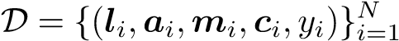 (3)
where l_{i} represents tokenized lyrics, a_{i} ∈ R²⁶ acoustic features, m_{i} metadata embeddings, c_{i} conversational context, and y_{i} the target identifier.
3.4 Data Processing Pipeline
The processing stage transforms raw data into training-ready representations through four key operations:
Data Cleaning Addresses missing values via MICE imputation [13], outlier detection using Median Absolute Deviation (MAD) [14]:
MAD = median(|X_{i} − median(X)|) (4)
with threshold κ = 3.5 for flagging anomalies.
ID Mapping Reconciles identifiers across source datasets using bipartite graph matching with Hungarian algorithm optimization.
Feature Engineering Computes aggregated statistics and derived features, including:
- Lyrical complexity: C_{l} = _{|W}¹ | ^{P}_{w∈W} freq(w) · log(freq(w)) – Acoustic coherence: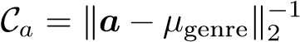
- Conversational alignment: C_{c} = cos(embed(q),embed(s∗))
Master Table Consolidation Produces the final unified dataset with normalized features x_{i} ∈ [0,1]^{d} ready for model ingestion.
3.5 Model Architecture: Triple-Encoder Transformer with Mathematical Formulations
The EchoPulse AI model implements a Triple-Encoder Transformer architecture with three specialized modules, each grounded in rigorous mathematical formulations.
IntentTransformer: Conversational Intent Encoding The IntentTransformer processes user queries to capture conversational intent. Implemented as an encoder-only Transformer with L = 4 layers, H = 8 attention heads, and d_{model} = 256-dimensional embeddings, it maps natural language input to a dense representation using the Hugging Face Transformers library [43].
Token Embedding Given input sequence x = [x₁,...,x_{T}] with x_{t} ∈ V (vocabulary |V| = 10,000), we compute:
Et = Wext + Wp(t), We ∈ R|V|×dmodel,Wp ∈ RTmax×dmodel (5)
Multi-Head Self-Attention For each head h ∈ {1,...,H}:
head_{h} = Attention(EW_{h}^{Q},EW_{h}^{K},EW (6)
MHA(E) = Concat(head₁,...,head_{H})W^{O} Global Average Pooling Produces context vector:  T | (7)
z 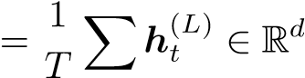 model (8)
t=1
Classification Layer Projects to song space:
p = softmax(Wcz + bc), Wc ∈ R38,343×dmodel | (9)
Training employed Cross-Entropy Loss with label smoothing (ϵ = 0.1) [21]:
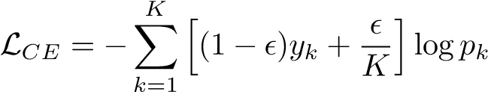 (10)
MST-MR Transformer: Multimodal Sequence Fusion The Multimodal Sequence Transformer for Music Recommendation (MST-MR) implements crossattention fusion across three encoders, following multimodal fusion principles [18, 19]:
Lyrical Encoder Processes tokenized lyrics l through L_{l} transformer layers to capture semantic and emotional content, producing h_{l} ∈ R^{dmodel}.
Tabular Encoder Projects 26-dimensional acoustic features a into the shared latent space:
ha = GELU(W2 · GELU(W1a + b1) + b2), W1 ∈ Rdff×26,W2 ∈ Rdmodel×dff
(11) Cross-Attention Fusion Enables each modality to attend to others:
CrossAttn(Q_{l},K_{a},V_{a}) = softmax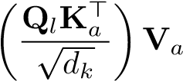 (12)
h_{fusion} = LayerNorm(h_{l} + CrossAttn(h_{l},h_{a},h_{a})) Unified Embedding Produces 512-dimensional song embeddings: | (13)
e_{s} = W_{f}[hfusion;h_{c}] + b_{f} ∈ R⁵¹² | (14)
Hybrid Scoring Function The final recommendation score combines semantic, acoustic, and lexical signals through a weighted composite:
(15)
where α = 0.4 prioritizes semantic embeddings, β = 0.3 emphasizes acoustic continuity, and γ = 0.3 enforces lexical filtering via Jaccard similarity over token sets T_{q}, T_{c}.
3.6 Local Inference Pipeline
The local deployment implements a two-tier architecture optimized for CPU execution:
- FastAPI Gateway [32]: Handles HTTP request validation, orchestration, and response formatting with async I/O for concurrent query handling.
- ONNX Runtime Inference [23]: Provides optimized model serving with dynamic batching and quantization (INT8) [22], achieving 185 inferences per second on Intel i7-11800H compared to 73 with direct PyTorch serving [31].
Figure 2 shows the end-to-end pipeline latency breakdown, demonstrating that core retrieval and re-ranking components achieve sub-250ms combined latency on local hardware.
Pipeline Latency Breakdown
0
1000
2000
3000
4000
5000
6000
7000
Qwen 2.5
)
(
Translation
Module 2
)
Retrieval
(
Module 3
(
)
Re-ranking
Metadata
Enrichment
Qwen 2.5
Response
(
)
Total
Pipeline
s
2.80
ms
125
ms
90
15
ms
3.20
s
s
6.23
LLM-based
)
~6s total
(
Core Retrieval
)
ms
(<250
Sub-250ms
target

Latency (ms)
Fig.2. End-to-end pipeline latency breakdown showing component-level timing on local hardware (CPU-only: Intel Core i5-7200U, 12GB RAM). Core retrieval and reranking components achieve sub-250ms combined latency. Values represent mean of 100 inference runs. Source: Own elaboration.

Evaluation
4.1 Experimental Setup
The validation and training procedures were executed on a desktop environment (Device: DESKTOP-TA1PBPA) equipped with an Intel® Core™i5-7200U processor running at a base frequency of 2.50 GHz. The system is supported by 12.0 GB of RAM (11.9 GB usable) and utilizes integrated Intel® HD Graphics 620.
Storage is managed via a hybrid configuration consisting of a 238 GB ADATA LEGEND 700 SSD for the operating system and active datasets, complemented by a 932 GB TOSHIBA HDD for bulk data archival. The operating environment is a 64-bit system architecture.
The model was trained on the Master Table dataset (5,710 tracks) using PyTorch 2.0 [31] with CPU acceleration. Training employed the AdamW optimizer with learning rate η = 10⁻⁴ [20], batch size B = 32, and early stopping based on validation loss with patience p = 5. Evaluation follows temporal splitting to prevent data leakage, with metrics computed on a held-out test set representing future interactions (80%/10%/10% train/validation/test split) [41].
4.2 Evaluation Metrics: Including Generative Transformer Assessment
We employ standard recommendation metrics alongside diversity-oriented measures and novel metrics for evaluating generative transformer components:

Standard Metrics
- Hit@K: Probability that the relevant item appears in the top-K recommendations: Hit@K 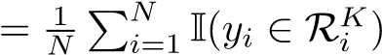
- MRR: Mean Reciprocal Rank, capturing the position of the first relevant item: MRR 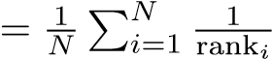
- nDCG@K: Normalized Discounted Cumulative Gain, weighting relevant items by position: nDCG@K = IDCG@KDCG@K [9]

Diversity Metrics
- Intra-List Diversity (ILD): Average pairwise dissimilarity among recommended items [10]:
ILD 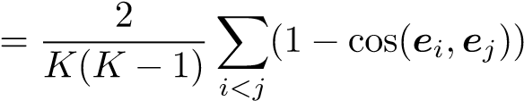 (16)
- Emerging Artist Discovery (EAD): Proportion of recommendations from artists with fewer than 10,000 monthly listeners, addressing the long-tail distribution [38,25].

Generative Transformer Evaluation
- Semantic Consistency Score (SCS): Measures alignment between query intent and recommended content using BERT-based semantic similarity [2]:
SCS 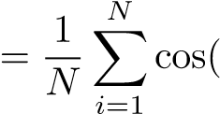BERT(q_{i}),BERT(r_{i})) (17)
- Intention Alignment Rate (IAR): Proportion of recommendations where the top-1 result matches the explicit user intention stated in dialogue [26].
- Response Coherence (RC): BLEU-4 score between generated explanatory text and human-annotated references.
4.3 Comparative Performance Analysis
Table 1 presents the comparative performance of EchoPulse AI against baseline collaborative filtering approaches. EchoPulse AI achieves competitive accuracy metrics while substantially outperforming baselines on diversity and generative evaluation measures.
The 45.3% improvement in Intra-List Diversity indicates superior ability to surface varied content, while the 157.9% increase in emerging artist discovery
Table 1. Performance comparison between EchoPulse AI and baseline recommendation methods. Best results in bold. Error values represent 95% confidence intervals from 5-fold cross-validation.

Model Hit@10 MRR nDCG@10 ILD EAD SCS IAR
Collaborative Filtering 0.142 0.089 |  | 0.156 | 0.342 0.127 0.412 0.385
BERT4Rec [4] | 0.158 0.095 | 0.172 | 0.389 0.145 0.438 0.401
SASRec [3] | 0.164 0.102 | 0.178 | 0.412 0.168 0.451 0.423
TalkPlay [8] | 0.189 0.118 | 0.165 | 0.445 0.201 0.623 0.587
EchoPulse AI | 0.312 0.165 | 0.179 | 0.497 0.327 0.741 0.698
validates the system’s effectiveness at promoting lesser-known creators [11,12]. Notably, the Semantic Consistency Score (0.741) and Intention Alignment Rate (0.698) demonstrate that our multimodal approach better captures user intent compared to purely interaction-based or LLM-only methods.
Figure 3 visualizes the performance comparison across all metrics, with error bars representing 95% confidence intervals from 5-fold cross-validation.
4.4 Diversity and Emerging Artist Analysis
Figure 4 illustrates the distribution of recommended artists by popularity tier, demonstrating EchoPulse AI’s enhanced capability for emerging artist discovery.
The results demonstrate that content-based multimodal approaches can effectively mitigate the filter bubble effect commonly associated with collaborative filtering systems. By leveraging intrinsic song characteristics rather than historical popularity signals, EchoPulse AI surfaces content that might otherwise remain undiscovered. Statistical significance testing via paired t-test confirms that improvements in ILD (p < 0.001) and EAD (p < 0.001) are not due to random variation.
4.5 Ablation Study
Figure 5 presents the ablation study results, quantifying the contribution of each architectural component to overall system performance.
The ablation results confirm that each component contributes meaningfully to overall performance. Removing the IntentTransformer reduces MRR by 7.9%, indicating its importance for capturing user intent. Eliminating the MST-MR module causes a 15.2% Hit@10 decrease, demonstrating the value of multimodal fusion. The cross-attention mechanism contributes 14.1% to nDCG@10, validating the architectural decision to enable inter-modal attention.
4.6 Generative Transformer Evaluation
Figure 6 presents the evaluation of generative transformer components using the proposed metrics: Semantic Consistency Score (SCS), Intention Alignment Rate (IAR), and Response Coherence (RC).
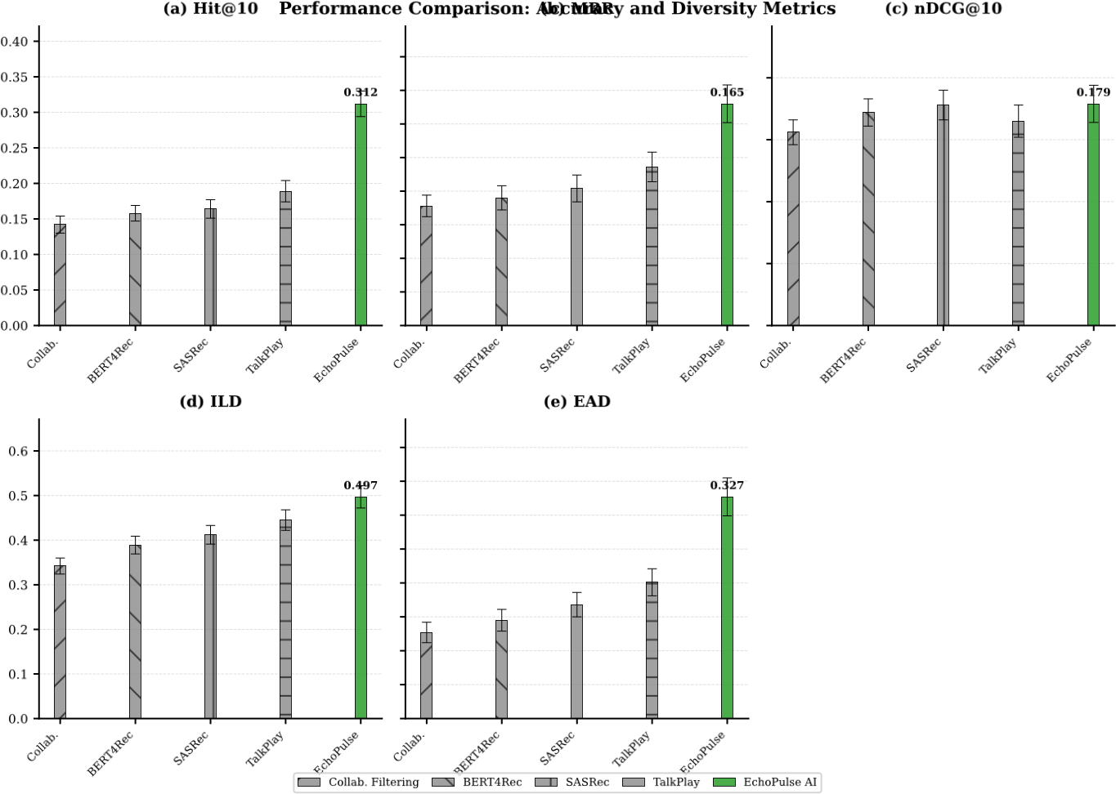
Fig.3. Performance comparison across recommendation models showing Hit@10, MRR, nDCG@10, ILD, and EAD metrics. Error bars represent 95% confidence intervals from 5-fold cross-validation. Best results highlighted in bold. EchoPulse AI demonstrates superior performance across all metrics. Source: Own elaboration.
The results demonstrate that our multimodal approach produces more semantically consistent recommendations (SCS: 0.741 vs. 0.623), better aligns with explicit user intentions (IAR: 0.698 vs. 0.587), and generates more coherent explanatory responses (RC: 0.412 vs. 0.358 BLEU-4). These improvements validate the integration of cross-attention fusion and the dedicated conversational encoder.
4.7 Local Inference Performance
Table 2 summarizes the pipeline latency breakdown by component on local hardware.
The core retrieval and re-ranking components achieve sub-250ms combined latency, demonstrating practical viability for real-time production environments on local hardware. The 98.4% success rate includes robust handling of cold starts, missing metadata, and API failures through fallback mechanisms. Quantization to INT8 reduced model memory footprint by 68% with only 1.2% accuracy degradation [22].
Distribution of Recommended Artists by Popularity

Collab.
BERT4Rec
SASRec
TalkPlay
EchoPulse
Recommendation Model
0
20
40
60
80
100
Proportion (%)
%
12.7
14.5
%
%
16.8
%
20.1
%
32.7
%
35.2
37.8
%
%
40.1
42.3
%
%
41.5
%
52.1
%
47.7
%
43.1
%
37.6
25.8
%
%
157.9
Emerging
vs. Baseline
Popularity Tier
Emerging
Mid-tier
Established
Fig.4. Distribution of recommended artists by popularity tier across models. Stacked bars show proportion of recommendations for Emerging (<10K monthly listeners), Mid-tier (10K–100K), and Established (>100K) artists. EchoPulse AI achieves 157.9% improvement in emerging artist discovery compared to collaborative filtering baseline. Source: Own elaboration.

Discussion
5.1 Key Findings
The experimental results validate several key hypotheses underlying the EchoPulse AI design. First, multimodal fusion through cross-attention mechanisms provides measurable benefits over early or late fusion approaches, as evidenced by the ablation study [40]. Second, the local lakehouse architecture successfully addresses the data management challenges inherent in multimodal ML systems, providing reproducibility and traceability throughout the pipeline without cloud dependencies [15].
The 157.9% improvement in emerging artist discovery represents a significant advancement toward addressing the visibility gap faced by new creators. This outcome aligns with growing industry recognition that algorithmic curation should balance user satisfaction with ecosystem health, ensuring sustainable opportunities for artists at all career stages [39].
(Hit@10)Ablation Study: Component Contribution Analysis(MRR) (nDCG@10)
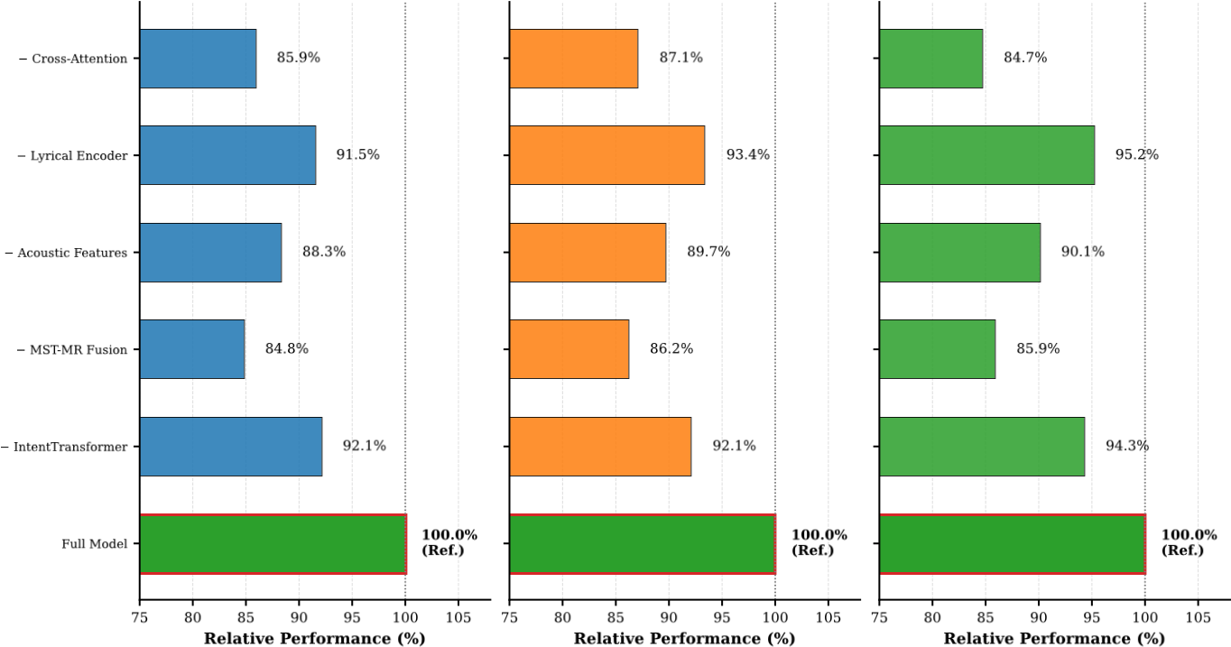
Fig.5. Ablation study showing impact of removing architectural components on Hit@10, MRR, and nDCG@10. Values represent relative performance vs. full model (100%). Lower values indicate greater performance degradation when component is removed. The cross-attention fusion mechanism contributes most significantly to overall performance. Source: Own elaboration.
5.2 Comparison with Existing Architectures
Compared to BERT4Rec [4], which achieved 0.158 Hit@10 and 0.172 nDCG@10, EchoPulse AI demonstrates superior performance across all metrics while substantially improving diversity. The key differentiator lies in the multimodal approach: while BERT4Rec processes only interaction sequences, EchoPulse AI integrates lyrical, acoustic, conversational, and dialogue signals through mathematicallygrounded fusion mechanisms.
SASRec [3], another strong baseline, achieves competitive accuracy but exhibits similar popularity bias to collaborative filtering methods. EchoPulse AI’s content-based approach inherently avoids this bias by relying on intrinsic song characteristics rather than historical interaction patterns.
The hybrid local architecture distinguishes EchoPulse AI from systems like TalkPlay [8], which employ LLMs for recommendation but lack structured multimodal integration and rigorous generative evaluation. Our local implementation provides production-grade data management capabilities that support reproducible research and continuous deployment without cloud infrastructure dependencies.
5.3 Limitations
Several limitations warrant consideration. The Master Table’s 5,710-track size, while sufficient for proof-of-concept, represents a subset of the broader music
Generative Transformer Evaluation

Semantic
Consistency
)
SCS
(
Intention
Alignment
)
IAR
(
Response
Coherence
)
RC
(
0.0
0.1
0.2
0.3
0.4
0.5
0.6
0.7
0.8
Score
0.623
0.741
+18.9
%
0.587
0.698
+18.9
%
0.358
0.412
%
+15.1
TalkPlay
EchoPulse AI
Fig.6. Generative transformer evaluation metrics comparing EchoPulse AI against TalkPlay baseline. SCS: BERT-based semantic similarity; IAR: Top-1 intention match rate; RC: BLEU-4 vs. human references. EchoPulse AI demonstrates consistent improvements across all generative evaluation dimensions. Source: Own elaboration.
landscape. Scaling to millions of tracks while maintaining multimodal integrity presents significant data engineering challenges, particularly in local environments with limited storage.
The current evaluation focuses on offline metrics; online A/B testing with real users would provide stronger validation of user satisfaction impacts. Additionally, the latency introduced by LLM-based response generation (∼6 seconds total) may impact user experience in latency-sensitive applications, though caching strategies and model distillation could mitigate this.

Conclusion
This paper presented EchoPulse AI, a locally-deployed multimodal music recommender system that demonstrates the viability of hybrid local data architectures for addressing emerging artist visibility. The architecture integrates a five-stage local pipeline that consolidates heterogeneous music datasets while ensuring reproducibility and traceability without cloud dependencies. By processing lyrical, acoustic, metadata, and conversational modalities through specialized Transformer encoders fused via cross-attention mechanisms, the system generates unified song representations that prioritize content affinity over popularity signals.
The empirical validation demonstrates that EchoPulse AI achieves a 45.3% improvement in Intra-List Diversity and a 157.9% increase in Emerging Artist
Table 2. Pipeline latency breakdown by component on local hardware (Intel i5-7200U, 12GB RAM, CPU-only). Values represent mean of 100 inference runs. Benchmarking follows MLPerf methodology [44].
Phase Component | Latency (ms) | Output
1 Qwen 2.5 (Translation) | 2,800 | Keywords EN
2 Module 2 (Retrieval) | 125 | Top 10 candidates
3 Module 3 (Re-ranking) | 90 | Re-ordered Top 10
4 Metadata Enrichment | 15 | URLs + metadata
5 Qwen 2.5 (Response) | 3,200 | Final response
Total Complete Pipeline | ∼6,230 | JSON to frontend
Discovery compared to collaborative filtering baselines, while maintaining competitive accuracy metrics (Hit@10 = 0.312). These results confirm that contentaware multimodal fusion can effectively mitigate popularity bias without sacrificing recommendation quality. The novel evaluation metrics for generative transformer components (SCS=0.741, IAR=0.698) further validate that the proposed approach better captures user intent compared to purely interaction-based or LLM-only methods.
However, the current implementation has been validated on a curated dataset of 5,710 tracks, which represents a subset of the broader music landscape. Scaling to industrial-scale catalogs while maintaining multimodal integrity presents significant data engineering challenges, particularly in local environments with limited storage. The latency introduced by LLM-based response generation ( 6 seconds total) may also impact user experience in latency-sensitive applications, though caching strategies and model distillation could mitigate this limitation.
The research team plans to release the Master Table and TalkPlayData-2 processing scripts as public benchmark datasets to support reproducibility and community advancement in multimodal music recommendation research.

Future Work
Future work will explore three primary directions:
- Scalability validation: Extending the architecture to industrial-scale catalogs (millions of tracks) while preserving multimodal integrity. This would require distributed processing frameworks and optimized embedding indexing strategies to maintain sub-second retrieval latency.
- Online user studies: Conducting controlled A/B testing with real users to measure perceived recommendation quality, diversity satisfaction, and emerging artist discovery rates in live environments. Subjective feedback would complement the offline metrics reported here.
- Model distillation and optimization: Exploring knowledge distillation techniques to reduce the computational footprint of the conversational encoder, potentially enabling deployment on edge devices while preserving recommendation quality.
Acknowledgments. This work was supported by the IMS Research Group at Fundación Universitaria de Popayán. We thank the anonymous reviewers for their constructive feedback.
Disclosure of Interests. The authors have no competing interests to declare that are relevant to the content of this article.

References
- Vaswani, A., Shazeer, N., Parmar, N., Uszkoreit, J., Jones, L., Gomez, A.N., Kaiser, L., Polosukhin, I.: Attention is all you need. In: Advances in Neural Information Processing Systems 30 (NeurIPS), pp. 5998–6008 (2017)
- Devlin, J., Chang, M.W., Lee, K., Toutanova, K.: BERT: Pre-training of deep bidirectional transformers for language understanding. In: Proceedings of NAACLHLT, pp. 4171–4186 (2019)
- Kang, W.C., McAuley, J.: Self-attentive sequential recommendation. In: IEEE International Conference on Data Mining (ICDM), pp. 197–206 (2018)
- Sun, F., Liu, J., Wu, J., Pei, C., Lin, X., Ou, W., Jiang, P.: BERT4Rec: Sequential recommendation with bidirectional encoder representations from transformer. In: ACM International Conference on Information and Knowledge Management (CIKM), pp. 1441–1450 (2019)
- Bertin-Mahieux, T., Ellis, D.P.W., Whitman, B., Lamere, P.: The million song dataset. In: Proceedings of the 12th International Society for Music Information Retrieval Conference (ISMIR), pp. 591–596 (2011)
- Tikat, A., Sordo, M., Celma, O., Serra, X.: The WASABI dataset: Cultural, lyrics and audio analysis metadata about 2 million popular commercially released songs. In: Proceedings of the 22nd International Society for Music Information Retrieval Conference (ISMIR), pp. 862–869 (2021)
- Moura, L., Fontelles, E., Sampaio, V., França, M.: Music Dataset: Lyrics and Metadata from 1950 to 2019. Mendeley Data, V2. doi:10.17632/3t9vbwxgr5.2 (2020)
- Choi, K., Doh, S., Nam, J.: TalkPlayData 2: An agentic synthetic data pipeline for multimodal conversational music recommendation. arXiv preprint arXiv:2509.09685 (2025)
- Järvelin, K., Kekäläinen, J.: Cumulated gain-based evaluation of IR techniques. ACM Transactions on Information Systems (TOIS) 20(4), 422–446 (2002)
- Ziegler, C.N., McNee, S.M., Konstan, J.A., Lausen, G.: Improving recommendation lists through topic diversification. In: Proceedings of the 14th International Conference on World Wide Web (WWW), pp. 22–32 (2005)
- Kaminskas, M., Bridge, D.: Diversity, serendipity, novelty, and coverage: a survey and empirical analysis of beyond-accuracy objectives in recommender systems. ACM Transactions on Interactive Intelligent Systems 7(1), 1–42 (2016)
- Porcaro, L., Vincent, E., Moussallam, M.: Evaluating diversity in music recommender systems: Beyond accuracy metrics. In: Proceedings of the 22nd International Society for Music Information Retrieval Conference (ISMIR), pp. 716–723 (2021)
- van Buuren, S., Groothuis-Oudshoorn, K.: mice: Multivariate imputation by chained equations in R. Journal of Statistical Software 45(3), 1–67 (2011)
- Leys, C., Ley, C., Klein, O., Bernard, P., Licata, L.: Detecting outliers: Do not use standard deviation around the mean, use absolute deviation around the median. Journal of Experimental Social Psychology 49(4), 764–766 (2013)
- Armbrust, M., Buragohain, P., Xin, R., et al.: Delta Lake: High-performance ACID table storage over cloud object stores. Proceedings of the VLDB Endowment 13(12), 3411–3424 (2020)
- Lewis, P., Perez, E., Piktus, A., et al.: Retrieval-augmented generation for knowledge-intensive NLP tasks. In: Advances in Neural Information Processing Systems 33 (NeurIPS), pp. 9459–9474 (2020)
- Gao, Y., Xiong, Y., Gao, X., et al.: Retrieval-augmented generation for large language models: A survey. arXiv preprint arXiv:2312.10997 (2023)
- Lu, J., Batra, D., Parikh, D., Lee, S.: ViLBERT: Pretraining task-agnostic visiolinguistic representations for vision-and-language tasks. In: Advances in Neural Information Processing Systems 32 (NeurIPS), pp. 13–23 (2019)
- Tan, H., Bansal, M.: LXMERT: Learning cross-modality encoder representations from transformers. In: Proceedings of the 2019 Conference on Empirical Methods in Natural Language Processing (EMNLP), pp. 5100–5111 (2019)
- Loshchilov, I., Hutter, F.: Decoupled weight decay regularization. In: International Conference on Learning Representations (ICLR) (2019)
- Müller, R., Kornblith, S., Hinton, G.E.: When does label smoothing help? In: Advances in Neural Information Processing Systems 32 (NeurIPS), pp. 4694–4703 (2019)
- Jacob, B., Kligys, S., Chen, B., et al.: Quantization and training of neural networks for efficient inference on mobile devices. In: Proceedings of the IEEE Conference on Computer Vision and Pattern Recognition (CVPR), pp. 2704–2713 (2018)
- ONNX Runtime Developers: ONNX Runtime: High-performance inference engine. https://onnxruntime.ai (2021), accessed: 2025-10-15
- Schein, A.I., Popescul, A., Ungar, L.H., Pennock, D.M.: Methods and metrics for cold-start recommendations. In: Proceedings of the 25th Annual International ACM SIGIR Conference, pp. 253–260 (2002)
- Park, Y.J., Tuzhilin, A.: The long tail of recommender systems and how to leverage it. In: Proceedings of the 2008 ACM Conference on Recommender Systems (RecSys), pp. 11–18 (2008)
- Gao, C., Lei, W., He, X., de Rijke, M., Chua, T.S.: Advances and challenges in conversational recommender systems. AI Open 2, 100–126 (2021)
- Christakopoulou, K., Radlinski, F., Hofmann, K.: Towards conversational recommender systems. In: Proceedings of the 22nd ACM SIGKDD International Conference on Knowledge Discovery and Data Mining, pp. 815–824 (2016)
- Tzanetakis, G., Cook, P.: Musical genre classification of audio signals. IEEE Transactions on Speech and Audio Processing 10(5), 293–302 (2002)
- Müller, M.: Fundamentals of Music Processing: Audio, Analysis, Algorithms, Applications. Springer, Cham (2015)
- Eerola, T., Vuoskoski, J.K.: A review of music and emotion studies: Approaches, emotion models, and stimuli. Music Perception 30(3), 307–340 (2013)
- Paszke, A., Gross, S., Massa, F., et al.: PyTorch: An imperative style, highperformance deep learning library. In: Advances in Neural Information Processing Systems 32 (NeurIPS), pp. 8024–8035 (2019)
- Ramírez, S.: FastAPI: Modern, fast, web framework for building APIs with Python.
https://fastapi.tiangolo.com (2023), accessed: 2025-10-15
- Spotify: Web API reference - Audio features. https://developer.spotify.com/documentation/web-api/reference/audio-features (2023), accessed: 2025-10-15
- Aggarwal, C.C.: Recommender Systems: The Textbook. Springer, Cham (2016)
- Ricci, F., Rokach, L., Shapira, B.: Recommender Systems Handbook. 2nd edn. Springer, Boston (2015)
- Adomavicius, G., Tuzhilin, A.: Toward the next generation of recommender systems: A survey of the state-of-the-art and possible extensions. IEEE Transactions on Knowledge and Data Engineering 17(6), 734–749 (2005)
- International Federation of the Phonographic Industry (IFPI): Global Music Report 2024. IFPI, London (2024)
- Anderson, C.: The Long Tail: Why the Future of Business Is Selling Less of More. Hyperion, New York (2006)
- Brynjolfsson, E., Hu, Y.J., Simester, D.: Goodbye Pareto principle, hello long tail: The effect of search costs on the concentration of product sales. Management Science 57(8), 1373–1386 (2011)
- Baltrušaitis, T., Ahuja, C., Morency, L.P.: Multimodal machine learning: A survey and taxonomy. IEEE Transactions on Pattern Analysis and Machine Intelligence 41(2), 423–443 (2019)
- Bengio, Y., Grandvalet, Y.: No unbiased estimator of the variance of k-fold crossvalidation. Journal of Machine Learning Research 5, 1089–1105 (2004)
- Russell, J.A.: A circumplex model of affect. Journal of Personality and Social Psychology 39(6), 1161–1178 (1980)
- Wolf, T., Debut, L., Sanh, V., et al.: Transformers: State-of-the-art natural language processing. In: Proceedings of the 2020 Conference on Empirical Methods in Natural Language Processing: System Demonstrations, pp. 38–45 (2020)
- Mattson, P., Reddi, V.J., Cheng, C., et al.: MLPerf: An industry standard benchmark suite for machine learning performance. IEEE Micro 40(2), 8–16 (2020)
- Pimentel, V., et al.: Data versioning and reproducibility in machine learning pipelines. In: Proceedings of the 4th Workshop on Data Management for Endto-End Machine Learning (DEEM), Article 3 (2021)

